**U.S. Secondary Mathematics Teachers' Perceptions vs. Achievement in Euclidean Geometry using a Web 2.0-based Supportive Tool**

**Abstract:** This paper discusses the current state of mathematics education in the United States and describes the results of a study to determine if relationships exist between achievement in a college Euclidean Geometry class and student perceptions toward and their perceived efficacy of a blogging activity that was a component of the course. The study which included a 12-week blogging activity was conducted at a university in the western United States. The use of powerful Web 2.0 technologies such as blogs is suggested as a possible means of strengthening the mathematics achievement of students of all levels, regardless of their relative strength in mathematics problem solving, reasoning, and understanding skills.

**Keywords:** Blog, Euclidean Geometry, preservice teachers, mathematics education, perceptions, Web 2.0

**Introduction**

Technology has been a powerful tool in the United States’ mathematics classrooms for several decades. Technology is one of the six principles included in the NCTM (National Council of Teachers of Mathematics) (2000) Principles and Standards of School Mathematics. The NCTM (2000) Principles and Standards suggests that “Technology is essential in teaching and learning mathematics; it influences the mathematics that is taught and enhances students’ learning” (p. 24). It also advocates for the appropriate and integrated use of technology in every aspect of mathematics education from what is taught in mathematics; how mathematics is taught and learned; and how mathematics is assessed (Powers & Blubaugh, 2005).

However, current progress in science, technology, and mathematics education in the U.S. is not satisfactory as evaluated by educators and legislators (Hossain & Robinson, 2011; Leshner, 2009). Although many U.S. students excel in mathematics, as a whole, U.S. performance on international mathematics tests consistently remains between the second and third quartile (Leshner, 2009). There are wide disparities in mathematics achievement among various ethnic groups. Too many U.S. students and parents think that mathematics is a difficult and uninteresting subject. The result is that mathematics education in the U.S. is failing to instill students with sufficient skills and knowledge necessary to meet the century’s challenging economy and leadership (Leshner, 2009).

Moreover, information technology has not reached its full potential in mathematics education programs across the United States (Gunter, 2001; Kurz & Middleton, 2006). Many prospective mathematics teachers’ views on the role of information technology in mathematics education are not satisfactory (Habre & Grunmeier, 2007). Habre and Grunmeier (2007) found that prospective mathematics teachers believe that they should use information technology to help teach students mathematics; and that mathematics and not information technology should remain the focus of instruction in mathematics classrooms. However, many of these preservice teachers believe that in many mathematics classrooms information technology is used improperly in ways that focus more on the technology than on mathematical understanding or calculation (Habre & Grunmeier, 2007). For instance, in an experiment, if students are shown tessellations of a plane using a web-based Java applet many participants may skip the mathematical knowledge behind the tessellation, since a Java applet may not show the mathematical calculation behind it (Habre & Grunmeier, 2007).

Studies also show that information technology is integrated inappropriately in many teacher education programs (Mistretta, 2005; Watts-Taffe, Gwinn, Johnson, & Horn, 2003). The preparation of preservice teachers to use information and communication technology is one of the critical challenges teacher education programs face (Powers & Blubaugh, 2005). Another study found that many teacher education programs use the computer as a teacher-centered tool rather than as a student-centered tool (Wang, 2002). Many information technology courses that are part of teacher preparation programs emphasize preservice teachers’ learning with technology rather than the integration of technology into their classroom teaching (Lederman & Neiss, 2000). Another study to measure preservice teachers’ technology beliefs, skills, and barriers to the use of information technology reports that many teacher education programs prepare preservice teachers with lower or outdated information and communication technology skills that do not provide preservice teachers adequate knowledge to provide sufficient information technology-based instruction in their classrooms (Brush, Glazewski, & Hew, 2008). Without adequate knowledge, these teachers get little opportunity to integrate information technology into their actual classrooms (Brush et al., 2008).

**Current State of Mathematics Education in the United States**

According to the report of the National Assessment of Educational Progress in 2007, 70% of U.S. eighth-grade students performed at or above the basic level in mathematics, and 31% performed at or above the proficient level (National Center for Educational Statistics, 2008). Even the eighth graders in the best-performing states such as Massachusetts rank significantly lower than the average eighth graders in the highest-achieving countries such as South Korea, Singapore, and Taiwan (Kuenzi, 2008). Compared to other industrialized nations, mathematics achievement of U.S. students appears inconsistent with a nation considered to be the world leader in scientific innovation (Hossain & Robinson, 2011).

Trends in International Mathematics and Science Study (TIMSS) results show that U.S. students’ progress and performance in mathematics is not satisfactory. The TIMSS report showed that in 1995, U.S. fourth-grade and eighth-grade students achieved an average score of 518 and 492 points respectively (TIMSS, 1995a, 1995b). In 1999, only eighth graders were tested, the average mathematics scores of U.S. eighth-graders was 502 (TIMSS, 1999); in 2003, the average mathematics scores of U.S. fourth-graders and eighth-graders were 518 and 504 respectively (TIMSS, 2003); and in 2007, these scores were 529 and 508 points respectively (TIMSS, 2007). In each year for each grade level those scores were compared with an international average that was normed at 500 points with a standard deviation of 100 points. A closer look at the results of past TIMSS studies is shown in Table 2.

|  |  |  |  |  |  |
| --- | --- | --- | --- | --- | --- |
| Table 2  U.S. Students’ Mathematics Performance Recorded in TIMSS 1995 – 2007 | | | | | |
| Assessment  Year | Participating Countries | U.S. Fourth-graders Score | Average Score | | U.S. Eighth-graders Score |
| M | SD |
| 1995 | 41 | 518 | 500 | 100 | 492 |
| 1999* | 38 | - | 500 | 100 | 502 |
| 2003 | 46 | 518 | 500 | 100 | 504 |
| 2007 | 48 | 529 | 500 | 100 | 508 |
| *In TIMSS 1999 only eighth graders were tested. | | | | | |

A superficial look at this table might mislead the reader into believing that the U.S. is doing well in mathematics. However, this would be a mistake as the improvement from 1995 to 2007 was not measureable. Although, both U.S. fourth- and eighth-graders improved in mathematics in 2007 compared to 1995, no measurable change was found in the percentage of either U.S. fourth- or eighth-graders performing at or above the advanced international benchmark in mathematics between 1995 and 2007 (grade four: 9 vs. 10 percent; grade eight: 4 vs. 6 percent) (TIMSS, 2007). Compared with the average score of 500 points in each grade with a standard deviation of 100 points, the U.S. fourth-graders’ average mathematics achievement on these tests was slightly higher; however, eighth-graders’ average achievement was close to the average level. In 2007, compared to the mathematics achievement of fourth-graders among the 36 participating countries, the average mathematics score of U.S. fourth-graders was higher than 23 out of the 35 other countries, lower than in eight countries, and not measurably different from the average scores of students in the remaining four countries; the average mathematics score of U.S. eighth-graders was higher than 37 of the 47 other countries, lower than in five countries, and not measurably different from the average scores of students in the remaining five countries (TIMSS, 2007).

Moreover, according to the Program for International Student Assessment (PISA), which is a system of international assessments that focuses on 15-year-old students’ scholastic performance on mathematics, science, and reading among the 35 Organisation for Economic Co-operation and Development (OECD) member nations and some other non-member nations, in 2003, 2006, and 2009, U.S. 15-year-old students’ combined mathematics scores were below the overall average score of 500 with a standard deviation of 100 in each of the assessments. A closer look at U.S. 15-year-old students’ mathematics performance in the past PISA studies is shown in Table 3.

|  |  |  |  |  |  |  |
| --- | --- | --- | --- | --- | --- | --- |
| Table 3  U.S. 15-year-old Students’ Mathematics Performance in PISA 2003 – 2009 | | | | | | |
| Assessment  Year | U.S.  Score | Average Score | | | Participating Countries | U.S.  Position |
| M | SD | |
| 2003 | 483 | 500 | | 100 | 41 | 24th |
| 2006 | 474 | 500 | | 100 | 57 | 32nd |
| 2009 | 496 | 500 | | 100 | 67 | 24th |

In PISA 2003, 15-year-old U.S. students’ average mathematics score was 483 compared to the overall average score of 500 with a standard deviation of 100. The U.S. 15-year-old students ranked 24th in average mathematics score among the 41 participating countries (Lemke et al., 2004). In PISA 2006, 15-year-old U.S. students’ average mathematics score was 474 compared to the OECD average mathematics score of 498 and that was in 32nd position among 57 participating countries (Baldi et al., 2007). In PISA 2009, U.S. 15-year-old students’ average mathematics score was 487 compared to the OECD average score of 496 and that was in 24th position among 67 participating countries (Fleischman, Hopstock, Pelczar, & Shelley, 2010).

Although U.S. 15-year-old students’ average mathematics score in 2009 was higher than their average mathematics score in 2006, it was not measurably different from its average mathematics score in 2003. U.S. 15-year-old students’ average mathematics scores were lower than the OECD average scores in each of the assessment years from 2003 to 2009. Only 27% of U.S. 15-year-old students scored at or above proficiency level four in mathematics – that was lower than the 32% of 15-year-old students in the OECD countries on average that scored at or above level four (Fleischman et al., 2010).

**Objective and Procedure**

The premise of this study is that mathematics education in the United States not only needs improvement but also often fails to take advantage of new technologies that could serve to enhance mathematics instruction and ultimately student learning. To initiate this line of investigation, this study sought to determine if relationships exist between student performance in mathematics and their perceptions of a blogging activity included as a regular component of the class. Specifically, the two research questions were:

(1) *Is there a relationship between the cumulative quiz scores attained by preservice mathematics teachers enrolled in a college Euclidean Geometry class and their attitudes toward the blogging activity in a college Euclidean Geometry class?*

(2) *Is there a relationship between the cumulative quiz scores attained by preservice mathematics teachers enrolled in a college Euclidean Geometry class and their perceptions of the effectiveness of the blog for the learning of Euclidean Geometry?*

To answer these research questions, a 12-week blogging activity was conducted as a standard component of a college Euclidean Geometry course offered for preservice secondary mathematics at a university in the western United States. The blog can be visited at: http://edsc353fall2011.wordpress.com/. At the end of the 12-week activity, preservice mathematics teachers’ perceptions, attitudes toward the blogging activity and perceived effectiveness of using the blogging activity, were measured using an instrument (Appendix-A) developed by the researchers. Validity and reliability of the instrument were measured through appropriate procedures and were found to be authentic and consistent. An electronic copy of the survey instrument can be seen at:

<http://edsc353fall2011.files.wordpress.com/2012/10/survey_instrument.pdf>

The first research question sought to determine if a relationship exists between participants’ median attitude scores regarding the blogging activity with their cumulative quiz total attained on the eight in-class quizzes. The second research question sought to determine if a relationship exists between participants’ median perceived effectiveness scores of the blogging activity. Participants’ attitude toward the blogging activity was measured by calculating the median response to 16 Likert-type scale items measured on a six-point scale, while participants’ perceived effectiveness of the blog for the learning of Euclidean Geometry was measured by calculating the median response on another 18 Likert-type scale items measured on a six-point scale. Due to the ordinal nature of the Likert-type scale data, a Spearman correlation r was used for these analyses

Prior to collecting data, permission was sought from the Institutional Review Board (IRB) of the university where the study was conducted. At the conclusion of the blogging activity, a survey was administered to collect data regarding preservice mathematics teachers’ perceptions of using a blog as a supportive teaching-learning tool in a college Euclidean Geometry course.

**Participants and Data**

The study was conducted in a college Euclidean Geometry course offered at a university in the western United States in the fall 2011 semester. There were 28 students who enrolled in and completed the class, all of whom participated in the study and survey. Descriptive statistics on the demographic information of study participants showed that twelve (42.86%) of the participants were male, and 16 (57.14%) were female. The participants ranged in age from 20 to 61 years old with a mean, median, and range of 26.43, 22.0, and 41 years respectively, and a standard deviation of 10.15 years. The participants reported their approximate average total time spent on the Internet per week in hours for all purposes that had mean, median, and range were 22.43, 20.50, and 55 hours respectively, with a standard deviation of 10.823 hours.

Participants were asked to respond to 16 specific questions (#s 8 to 23, see in Appendix-A) designed to measure their attitudes toward the blogging activity in a college Euclidean Geometry course. These questions included a 6-point Likert-type scale allowing participants to indicate whether they Very Strongly Agree (VSA), Strongly Agree (SA), Agree (A), Disagree (D), Strongly Disagree (SD), or Very Strongly Disagree (VSD) to each item. These sixteen 6-point Likert-type scale items were combined to attain a median attitude score toward the blogging activity in the college Euclidean Geometry course for each participant. The possible attitude score for each item was 1 to 6 with a higher number representing a more positive attitude toward the blogging activity for the learning of college Euclidean Geometry. For positively worded items, 1 indicated Very Strongly Disagree (VSD) and 6 indicated Very Strongly Agree (VSA). There were 6 negatively worded Likert-type scale items (items numbers 9, 11, 13, 16, 19, and 23) in this section. The same Likert scale options were given for the six negatively worded Likert-type scale items; however, those items were coded in reverse order. The median score on the 16-question attitude survey was determined for each participant.

The participants also responded to 18 specific questions (#s 24 to 41, see in Appendix-A) pertaining to the perceived effectiveness of the blog for the learning of Euclidean Geometry. These questions included a 6-point Likert-type scale allowing participants to indicate whether they Very Strongly Agree (VSA), Strongly Agree (SA), Agree (A), Disagree (D), Strongly Disagree (SD), or Very Strongly Disagree (VSD) to each item. These eighteen 6-point Likert-type scale items were combined to attain a median perceived effectiveness score of using the blog for the learning of Euclidean Geometry for each participant. Each item had a possible range of 1 to 6; where 1 indicated Very Strongly Disagree (VSD) and 6 indicated Very Strongly Agree (VSA). All items in this section were worded positively. The possible range for the perceived effectiveness score for each item was 1 to 6 with a higher number representing a more positive perceived effectiveness of the blog for the learning of Euclidean Geometry. The median score on the 18-question perceived effectiveness survey was determined for each participant.

| Table 1  Descriptive Statistics of Attitude and Perceived Effectiveness Scores | | |
| --- | --- | --- |
|  | Attitude Scores | Perceived Effectiveness |
| Valid N | 28 | 28 |
| Mean | 4.18 | 4.1 |
| Median | 4.0 | 4.0 |
| Mode | 4.00 | 4.0 |
| Std. Deviation | .95 | .93 |

Table 1 shows an overall measure of the median attitude and median perceived effectiveness scores. Descriptive statistics of the median attitude scores yielded a mean, median, and mode of 4.18, 4.0, and 4.0, respectively, with a standard deviation of 0.95. This indicates that the typical response of participants corresponds to slightly more than agreement that they held a positive attitude toward the blogging activity in the College Euclidean Geometry course. Similarly, descriptive statistics of the median perceived effectiveness scores yielded a mean, median, and mode of 4.13, 4.0, and 4.0, respectively, with a standard deviation of 0.93, indicating that the typical response of participants corresponds to slightly more than agreement that the blogging activity was an effective means of teaching and learning Euclidean Geometry.

It was mentioned that among the 16 attitude measuring items there were ten positively worded Likert-type scale items. Those are noted as: Q8, Q10, Q12, Q14, Q15, Q17, Q18, Q20, Q21, and Q22. For the positively worded items, participants’ responses were inclined towards *Agree* (A) to *Strongly Agree* (SA) options (Figure -1).

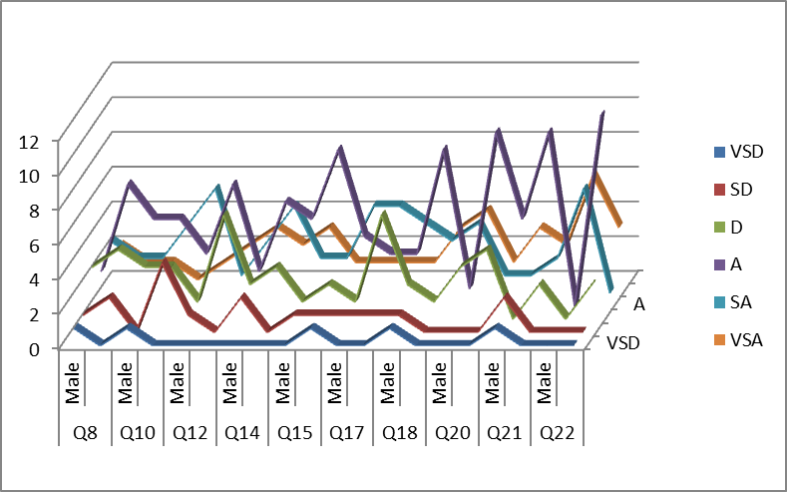

Figure -1: 3-D Line Graph of the Positively Worded Attitude Measuring Scores

On the other hand, for the negatively worded items: Q9, Q11, Q13, Q16, Q19, and Q23 participants’ responses were inclined towards Disagree (D) to Very *Strongly Disagree* (VDA) options (Figure -2). In both cases, it is obvious that participants’ overall responses indicated that they had positive attitude toward using the blogging activity.

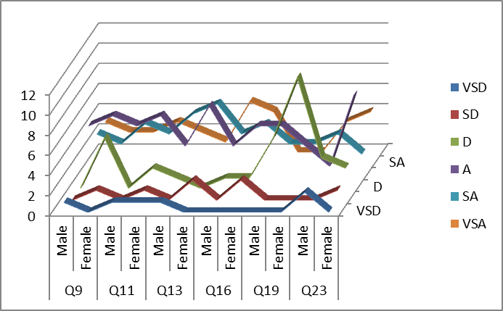

Figure -2: 3-D Line Graph of the Negatively Worded Attitude Measuring Scores

All 18 perception measuring items were worded positively. For, participants’ responses were inclined towards *Agree* (A) to *Strongly Agree* (SA) options (Figure -3). This meant that participants’ overall responses indicated that they had positive perceptions toward the effectiveness of blogging activity.

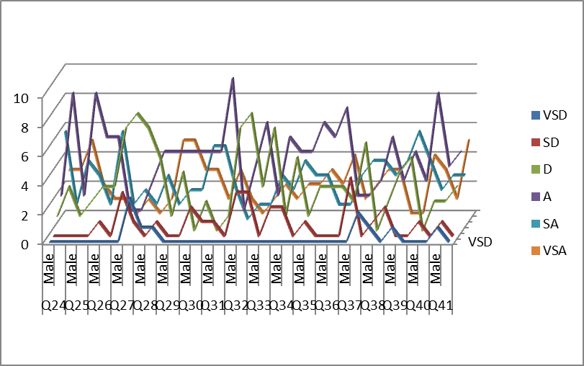

Figure-3: 3-D Line Graph of the Effectiveness Measuring Scores

Among the 16 attitude measuring items there were ten positively worded Likert-type scale items. Those are noted as: Q8, Q10, Q12, Q14, Q15, Q17, Q18, Q20, Q21, and Q22. For those items, participants’ responses were inclined towards *Agree* (A) to *Strongly Agree* (SA) options (Figure -1).

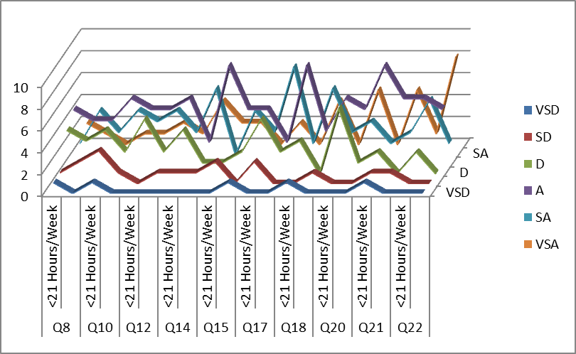

Figure -1: 3-D Line Graph of the Positively Worded Attitude Measuring Scores

For the remaining six negatively worded items: Q9, Q11, Q13, Q16, Q19, and Q23 participants’ responses were inclined towards *Agree* (A) to *Strongly Agree* (SA) options (Figure -1).

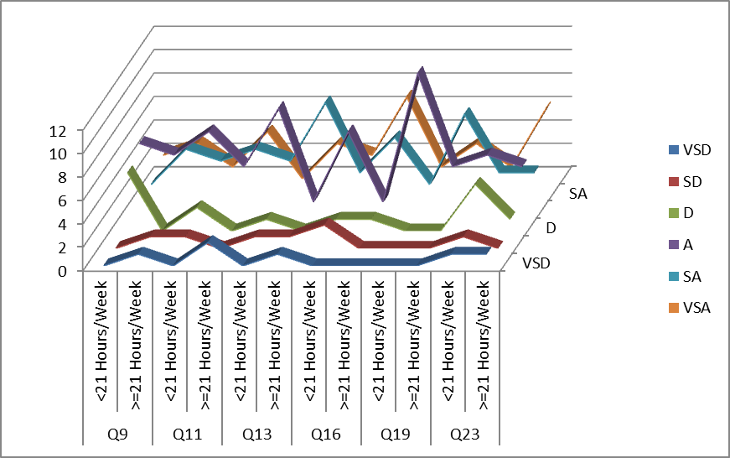

All 18 perception measuring items were worded positively. For, participants’ responses were inclined towards *Agree* (A) to *Strongly Agree* (SA) options (Figure -3). This meant that participants’ overall responses indicated that they had positive perceptions toward the effectiveness of blogging activity.

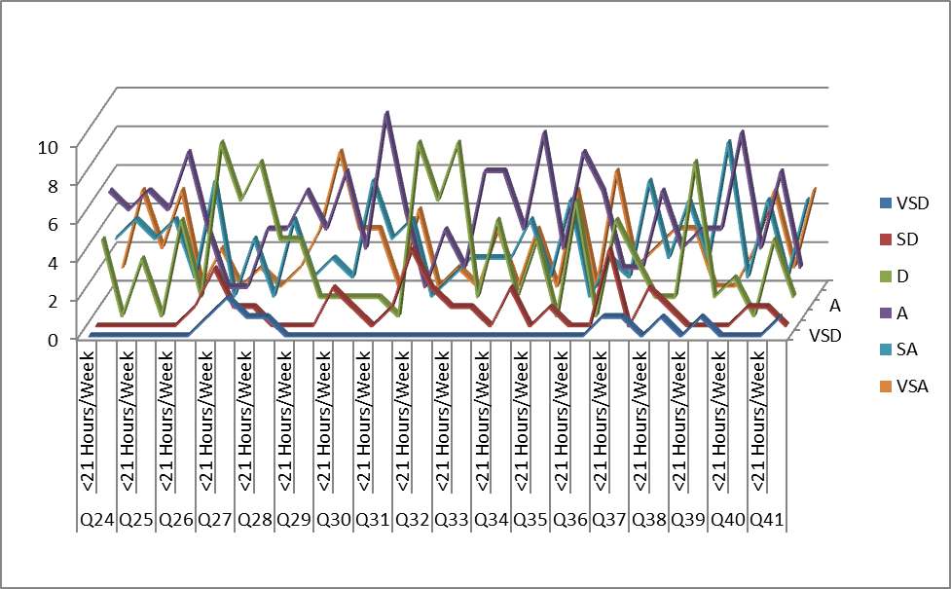

Figure-3: 3-D Line Graph of the Effectiveness Measuring Scores

**Findings and Discussion**

**Use and Impact of a Blogging Activity on Students’ Mathematics Achievement**

The first research question was: Is there a relationship between the cumulative quiz scores attained by preservice mathematics teachers enrolled in a college Euclidean Geometry class and their attitudes toward the blogging activity in a college Euclidean Geometry class? The data (Table 4) for this research question were analyzed by calculating a non-parametric Spearman correlation r on cumulative quiz scores and median attitude scores.

|  |  |  |
| --- | --- | --- |
| Table 4  Cumulative Quiz Scores vs. Median Attitude and Perceived Effectiveness Scores | | |
| Cumulative  Quiz Scores | Median  Attitude Scores | Median Perceived Effectiveness Scores |
| 74.5 | 6.0 | 4.0 |
| 77.5 | 6.0 | 4.0 |
| 73.0 | 4.0 | 5.0 |
| 80.0 | 4.0 | 4.0 |
| 76.0 | 3.0 | 3.0 |
| 66.5 | 4.0 | 4.0 |
| 70.0 | 5.0 | 5.0 |
| 49.0 | 5.0 | 6.0 |
| 64.0 | 4.0 | 4.0 |
| 33.0 | 5.0 | 4.0 |
| 58.5 | 4.0 | 4.0 |
| 78.0 | 3.0 | 3.0 |
| 72.5 | 4.0 | 5.0 |
| 70.5 | 4.0 | 4.0 |
| 69.5 | 3.0 | 4.0 |
| 65.0 | 3.0 | 3.0 |
| 58.5 | 4.5 | 5.0 |
| 64.5 | 6.0 | 6.0 |
| 65.5 | 4.0 | 3.5 |
| 73.5 | 5.0 | 5.0 |
| 67.5 | 4.0 | 5.0 |
| 73.0 | 5.0 | 5.0 |
| 77.0 | 3.5 | 3.5 |
| 60.5 | 4.0 | 4.0 |
| 68.5 | 4.0 | 3.0 |
| 72.5 | 4.0 | 3.5 |
| 70.5 | 2.0 | 2.0 |
| 72.0 | 4.0 | 4.0 |
| N = 28 | N = 28 |  |

| Table 5  Spearman Correlation Test Results on Median Attitude Scores | | | |
| --- | --- | --- | --- |
| Spearman's rho |  | Cumulative Quiz Score | rs |
| Cumulative Quiz Score | Correlation Coefficient | 1.000 | -.145 |
| Sig. (2-tailed) | . | .461 |
| N | 28 | 28 |
| Median  Attitudes | Correlation Coefficient | -.145 | 1.000 |
| Sig. (2-tailed) | .461 | . |
| N | 28 | 28 |

The Spearman correlation test result (Table 5) indicated a non-significant correlation (N = 28, rs = -0.145, *p* >.05) that failed to reject the null hypothesis that there is no relationship between the cumulative quiz scores attained by preservice mathematics teachers enrolled in a college Euclidean Geometry class and their attitudes toward the blogging activity in a college Euclidean Geometry class. This means that the study did not find a significant correlation between attitudes toward the blog and total quiz score measured by eight in-class quizzes.

The second research question was: Is there a relationship between the cumulative quiz scores attained by preservice mathematics teachers enrolled in a college Euclidean Geometry class and their perceptions of the effectiveness of the blog for the learning of Euclidean Geometry? The data (Table 4) for this research question were analyzed by calculating a non-parametric Spearman correlation r on cumulative quiz scores and median perceived effectiveness scores.

The Spearman correlation test result (Table 6) indicated a non-significant correlation (N = 28, rs = -0.232, *p* >.05) that failed to reject the null hypothesis that there is no relationship between the cumulative quiz scores attained by preservice mathematics teachers enrolled in a college Euclidean Geometry class and their perceptions of the effectiveness of the blog for the learning of Euclidean Geometry. This means that the study did not find a significant correlation between perceived effectiveness of the blog and total quiz score measured by eight in-class quizzes.

| Table 6  Spearman Correlation Test Results on Median Perceived Effectiveness Scores | | | | |
| --- | --- | --- | --- | --- |
| Spearman's rho |  | Cumulative  Quiz Score | rs | |
| Cumulative Quiz Score | Correlation Coefficient | 1.000 | -.232 |
| Sig. (2-tailed) | . | .235 |
| N | 28 | 28 |
| Median  Effectiveness | Correlation Coefficient | -.232 | 1.000 |
| Sig. (2-tailed) | .235 | . |
| N | 28 | 28 |

**Discussion and Implication of the Study**

Analysis of the first research question: Is there a relationship between the cumulative quiz scores attained by preservice mathematics teachers enrolled in a college Euclidean Geometry class and their attitudes toward the blogging activity in a college Euclidean Geometry class?, did not indicate a significant correlation (N = 28, rs = -0.145, *p* >.05) between the participants cumulative quiz scores and their median attitude scores toward the blogging activity. Similarly, analysis of the second research question: Is there a relationship between the cumulative quiz scores attained by preservice mathematics teachers enrolled in a college Euclidean Geometry class and their perceptions of the effectiveness of the blog for the learning of Euclidean Geometry?, did not indicate a significant correlation (N = 28, rs = -0.232, *p* >.05) between the participants cumulative quiz scores and their median perceived effectiveness scores toward the blogging activity. These finding coincide with Cash’s (2010) doctoral dissertation research that found that Web 2.0 usage level did not have a significant relationship with high school students’ letter grade (performance) in mathematics, science, and social studies.

Although in many instances, non-significant results aren’t particularly useful with regard to informing practice, in this study, combining the non-significant results with the descriptive statistics is quite revealing. The descriptive statistics gathered in this study indicate that participants considered the blogging activity to be enjoyable and perceived it to be effective with regard to the teaching and learning of Geometry. Combining these strong descriptive findings with the non-significant results to the two research questions suggest that all participants, regardless of their relative performance on the quizzes, enjoyed and perceived benefits from participating in the blogging activity. Thus, we can conclude that relative strength in mathematical problem-solving, reasoning, and understanding skills should not be considered as a determining factor with regard to the benefits of using a blogging activity.

Thus, we can conclude that the level of mathematical content knowledge and/or problem-solving skills are not determining factors regarding whether or not a blogging activity will be enjoyed by and perceived to be effective by students in a mathematics class. This conclusion suggests that teachers should implement blogging activities in their low level classes as well as their upper level classes, as all students are equally likely to benefit. Unfortunately, we have all heard stories of upper level classes being provided with interesting activities while lower level classes are often relegated to completing boring worksheets under the guise that these students couldn’t handle the more interesting activities. This study directly refutes this idea and provides a strong justification for implementing blogging activities with classes of all levels.

Limitations of the Study

The main limitation of this study was that it dealt with a single medium sized class of 28 students in a college Euclidean Geometry course. Moreover, due to the nature of the ordinal nature of the dependent variable that was used to measure participants’ perceived effectiveness of using the blogging activity, it was not possible for the researchers to use more powerful parametric tests for analyzing quantitative data. Thus, the non-parametric Wilcoxon-Mann-Whitney U test, which is considered less powerful than the corresponding parametric t-test, was used to analyze the research questions. Due to limited sample size, this study has only about 51% chance of getting a significant mean difference between the groups, if that difference really existed. Thus, the findings of this study cannot be claimed as generalizable; and the researchers suggest implementing this or similar studies in a broad range. Finally, this study did not use a control group, therefore, the researchers were not able to compare the participating (treatment group) students’ perceived effectiveness of using the blogging activity with another group (control group) of students who did not participate in the blogging activity.

## Conclusions

This study has indicated some important and notable results regarding the use of blogs in teaching-learning Geometry and other mathematics courses. As most of the participants in this study were preservice mathematics teachers, their perceptions were related to both teaching and learning perspectives. Quantitative measures of participants’ attitudes toward and perceived effectiveness indicated that the use of a blog is both enjoyable, and perceived to be effective in a college Euclidean Geometry course.

The study, also, indicated that students’ mathematical content knowledge, problem solving, and understanding skills are not a significant factor with regard to using a blog as a supportive teaching-learning tool in a Euclidean Geometry course. This means that mathematics teachers who want to use a blogging activity in their courses should not be concerned about whether the participants have a strong or weak background in mathematics. Through active collaboration and increased engagement both strong and weak students will enjoy and potentially benefit from the use of a blog as a supportive learning tool.

**References**

Baldi, S., Jin, Y., Skemer, M., Green, P., Herget, D., & Xie, H. (2007). *Highlights from PISA 2006: Performance of US 15-year old students in science and mathematics literacy in an international context*. Washington, DC: National Center for Education Statistics, US Department of Education.

Brush, T., Glazewski, K. D., & Hew, K. F. (2008). Development of an Instrument to Measure Preservice Teachers’ Technology Skills, Technology Beliefs, and Technology Barriers. *Computers in the Schools, 25*(1), 112-125.

Cash, J. C. (2010). *Web 2.0 and self-reported student performance among high school students in rural schools.* (Doctoral Dissertation. UMI #3416273), The University of Southern Mississippi, Mississippi - United States. Retrieved from http://proquest.umi.com/pqdweb?did=2100301511&Fmt=7&clientId=1846&RQT=309&VName=PQD

Fleischman, H. L., Hopstock, P. J., Pelczar, M. P., & Shelley, B. E. (2010). *Highlights From PISA 2009: Performance of U.S. 15-year-old students in reading, mathematics, and science literacy in an international context*. Retrieved August 18, 2011, from http://nces.ed.gov/pubs2011/2011004.pdf

Gunter, G. (2001). Making a difference: Using emerging technologies and teaching strategies to restructure an undergraduate technology course for preservice teachers. *Education Media International, 38*(1), 13–20.

Habre, S., & Grunmeier, T. A. (2007). Prospective Mathematics Teachers’ Views on the Role of Technology in Mathematics Education. *IUMPST: The Journal, 3*(Technology), Retrieved August 31, 2011, from http://www.k-2012prep.math.ttu.edu/journal/technology/habre2001/article.pdf.

Hossain, M. M., & Robinson, M. G. (2011). Is the U.S. Plan to Improve its Current Situation in Science, Mathematics, and Technology Achievable? *US-China Education Review, 1*(1), 1-9.

Kuenzi, J. J. (2008). Science, Technology, Engineering, and Mathematics (STEM) Education: Background, Federal Policy, and Legislative Action. *CRS report for Congress.* Retrieved October 20, 2009, from http://www.fas.org/sgp/crs/misc/RL33434.pdf

Kurz, T. L., & Middleton, J. A. (2006). Using a Functional Approach to Change Preservice Teachers' Understanding of Mathematics Software. *Journal of Research on Technology in Education, 39*(1), 45-65.

Lederman, N., & Neiss, L. (2000). Technology for technology’s sake or for the improvement of teaching and learning? *School Science and Mathematics, 100*(7), 345–348.

Lemke, M., Sen, A., Pahlke, E., Partelow, L., Miller, D., Williams, T., . . . Jocelyn, L. (2004). *International Outcomes of Learning in Mathematics Literacy and Problem Solving: PISA 2003 results from the U.S. perspective*. Washington, DC: U.S. Department of Education, National Center for Education Statistics, Institute of Education Sciences.

Leshner, A. (2009). A wake-up call for science education. *The Boston Globe. January 12, 2009.* Retrieved March 11, 2009, from http://www.boston.com/bostonglobe/editorial_opinion/oped/articles/2009/01/12/a_wake_up_call_for_science_education/

Mistretta, R. M. (2005). Integrating technology into the mathematics classroom: The role of teacher preparation programs. *The Mathematics Educator, 15*(1), 18-24.

National Center for Educational Statistics. (2008). *Digest from Education Statistics: 2007.* Retrieved March 18, 2009, from http://www.nces.ed.gov/programs/digest/d07/

National Council of Teachers of Mathematics (NCTM). (2000). *Principles and Standards for School Mathematics*. Reston, VA: Author.

Powers, R., & Blubaugh, W. (2005). Technology in Mathematics Education: Preparing teachers for the future. *Contemporary Issues in Technology and Teacher Education, 5*(3/4), 254-270.

TIMSS. (1995a). *Highlights of Results: The middle school years.* Retrieved December 12, 2008, from http://pirls.bc.edu/timss1995i/HiLightB.html

TIMSS. (1995b). *Highlights of Results: The primary school years.* Retrieved December 12, 2008, from http://pirls.bc.edu/timss1995i/HiLightA.html

TIMSS. (1999). *International Student Achievement in Mathematics.* Retrieved 12, 2008, from http://timss.bc.edu/timss1999i/pdf/T99i_Math_01.pdf

TIMSS. (2003). *International Student Achievement in Mathematics.* Retrieved December 12, 2008, from http://timss.bc.edu/PDF/t03_download/T03_M_Chap1.pdf

TIMSS. (2007). *Average Mathematics Scores of Fourth- and Eighth-grade Students, by Country: 2007.* Retrieved December 12, 2008, from http://nces.ed.gov/timss/table07_1.asp

Wang, Y. (2002). When Technology Meets Beliefs: Preservice teachers’ perception of the teacher’s role in the classroom with computers. *Journal of Research on Computing in Education, 35*(1).

Watts-Taffe, S., Gwinn, C., Johnson, J. R., & Horn, M. (2003). Preparing preservice teachers to integrate technology with the elementary literacy program: The experiences of three beginning teachers raise important issues for teacher educators. *The Reading Teacher, 57*(2), 130-139.

## Appendix A: Survey Instrument

Please fill out this questionnaire based on your perceptions of the blogging activity in the course, EDSC 353: Teaching Secondary Geometry, in the fall semester of 2011.

## I. Demographic Information

1. Please indicate your gender: 􀂆 Male 􀂆 Female

2. Please state your age: ___________ years.

**II. Experience in using Internet and Web 2.0 Application**

3. Do you use a Smartphone or Internet connected cell handheld device to get access to the Internet?

􀂆 Yes 􀂆 No 􀂆 I do not use a cell phone

4. How much total time do you spend per week on the Internet for all purposes? __________ hours.

5. How do you rate your skills in using the Internet in terms of sending or receiving emails, browsing webpages, searching information, reading news on the Internet, etc.?

􀂆 Excellent 􀂆 Good 􀂆 Fair

6. How do you rate your interest/engagement in Web 2.0 applications such as: blog, Facebook, podcast, twitter, wikis, etc.?

􀂆 Very Much 􀂆 Average 􀂆 Very Little

7. Before participating in this activity how much experience in blogging did you have?

􀂆 Very Much 􀂆 Average 􀂆 Very Little

**III. Attitudes toward the Blogging Activity**

In this section, please express your response in **only one** of the following options:

*VSA* = Very Strongly Agree *SA* = Strongly Agree

*A* = Agree *D* = Disagree

*SD* = Strongly Disagree V*SD* = Very Strongly Disagree

|  |  |  |  |  |  |  |  |
| --- | --- | --- | --- | --- | --- | --- | --- |
| **#** | **Question** | **Response** | | | | | |
| 8. | Participating in this blogging activity peaked my interest to learn how to conduct such an activity | VSA | SA | A | D | SD | VSD |
| 9. | The blogging activity made me irritable | VSA | SA | A | D | SD | VSD |
| 10. | After participating in this blogging activity I hope to see blogging activities in other mathematics courses I take in future | VSA | SA | A | D | SD | VSD |
| 11. | I did not like participating in the blogging activity | VSA | SA | A | D | SD | VSD |
| 12. | I enjoyed spending time online for this blogging activity | VSA | SA | A | D | SD | VSD |
| 13. | The blogging activity was not worth the time and effort it involved | VSA | SA | A | D | SD | VSD |
| 14. | I enjoyed reading solutions that my classmates posted on the blog | VSA | SA | A | D | SD | VSD |
| 15. | I enjoyed posting topics or issueson the discussion board of the blog | VSA | SA | A | D | SD | VSD |
| 16. | I felt uncomfortable participating in the blogging activity | VSA | SA | A | D | SD | VSD |
| 17. | I enjoyed commenting on my classmates’ contributions to the blog | VSA | SA | A | D | SD | VSD |
| 18. | The blogging activity was interesting | VSA | SA | A | D | SD | VSD |
| 19. | The blogging activity did not fulfill my initial expectations about it | VSA | SA | A | D | SD | VSD |
| 20. | Blogging activities should be incorporated into other courses in the teacher education program | VSA | SA | A | D | SD | VSD |
| 21. | I enjoyed posting solutions to the blog | VSA | SA | A | D | SD | VSD |
| 22. | I felt comfortable with the blogging activity | VSA | SA | A | D | SD | VSD |
| 23. | The blogging activity was boring | VSA | SA | A | D | SD | VSD |

**IV. Effectiveness of the Blogging Activity for Learning Euclidean Geometry**

In this section, please express your response in **only one** of the following options:

*VSA* = Very Strongly Agree *SA* = Strongly Agree

*A* = Agree *D* = Disagree

*SD* = Strongly Disagree V*SD* = Very Strongly Disagree

|  |  |  |  |  |  |  |  |
| --- | --- | --- | --- | --- | --- | --- | --- |
| **#** | **Question** | **Response** | | | | | |
| 24. | The blog provided me with an interactive tool for online learning | VSA | SA | A | D | SD | VSD |
| 25. | The blogging activity encouraged me to share my ideas with other students in the course | VSA | SA | A | D | SD | VSD |
| 26. | The blogging activity helped me understand difficult problems in easier ways | VSA | SA | A | D | SD | VSD |
| 27. | The online discussion on the blog was more effective for learning Euclidean Geometry than in class discussion | VSA | SA | A | D | SD | VSD |
| 28. | The blogging activity helped me get better scores on the quizzes | VSA | SA | A | D | SD | VSD |
| 29. | My contributions to the blog increased the learning experience of other students in the course | VSA | SA | A | D | SD | VSD |
| 30. | Writing a substantive comment to someone’s solution on the blog encouraged me to think of an alternative solution to a problem | VSA | SA | A | D | SD | VSD |
| 31. | The blogging activity helped me figure out how a specific problem could be solved in different ways | VSA | SA | A | D | SD | VSD |
| 32. | Solving a problem on the blog was more effective for learning Euclidean Geometry than solving a problem face-to-face in class | VSA | SA | A | D | SD | VSD |
| 33. | The blogging activity encouraged me to try other Web 2.0 technologies for teaching and learning Euclidean Geometry | VSA | SA | A | D | SD | VSD |
| 34. | The contributions of my classmates to the blog helped me learn something new about Euclidean Geometry | VSA | SA | A | D | SD | VSD |
| 35. | The blogging activity helped me better understand some concepts of Euclidean Geometry | VSA | SA | A | D | SD | VSD |
| 36. | My contributions to the blog helped other students in the class learn something new about Euclidean Geometry | VSA | SA | A | D | SD | VSD |
| 37. | The blogging activity helped me better utilize my leisure time for learning purposes | VSA | SA | A | D | SD | VSD |
| 38. | The blogging activity encouraged me to collaborate with other students in the class | VSA | SA | A | D | SD | VSD |
| 39. | The blogging activity provided me with some lifelong understanding of Euclidean Geometry | VSA | SA | A | D | SD | VSD |
| 40. | The blogging activity created a collaborative learning environment in the Euclidean Geometry course | VSA | SA | A | D | SD | VSD |
| 41. | The blogging activity was more effective for learning Euclidean Geometry than writing reflection papers on class readings | VSA | SA | A | D | SD | VSD |

*Thank you for your participation.*

Appendix: *An Overview of Participants’ Perception Scores Obtained from the Survey*

|  |  |  |  |  |  |  |  |  |  |  |  |  |  |  |  |  |  |  |  |
| --- | --- | --- | --- | --- | --- | --- | --- | --- | --- | --- | --- | --- | --- | --- | --- | --- | --- | --- | --- |
|  | Table AA: *An Overview of Participants’ Attitude Scores toward the Blogging Activity* | | | | | | | | | | | | | | | | | | |
| Participants | |  | Items in the Survey Instrument Pertaining to the Measurement of Attitude | | | | | | | | | | | | | | | | Median |
| No. | Gender | Time | 8 | 9 | 10 | 11 | 12 | 13 | 14 | 15 | 16 | 17 | 18 | 19 | 20 | 21 | 22 | 23 |
| 1 | M | >=21 | 5 | 6 | 6 | 6 | 5 | 6 | 6 | 5 | 6 | 5 | 5 | 6 | 6 | 6 | 6 | 6 | 6 |
| 2 | M | >=21 | 3 | 5 | 4 | 6 | 5 | 6 | 6 | 6 | 5 | 6 | 6 | 5 | 6 | 6 | 6 | 6 | 6 |
| 3 | F | <21 | 4 | 3 | 5 | 6 | 5 | 4 | 4 | 4 | 5 | 3 | 4 | 4 | 4 | 4 | 4 | 6 | 4 |
| 4 | F | <21 | 5 | 4 | 4 | 4 | 4 | 4 | 5 | 4 | 2 | 4 | 4 | 4 | 4 | 4 | 4 | 4 | 4 |
| 5 | F | <21 | 4 | 3 | 2 | 3 | 3 | 4 | 3 | 2 | 2 | 2 | 4 | 4 | 3 | 4 | 4 | 4 | 3 |
| 6 | F | <21 | 4 | 4 | 3 | 4 | 3 | 4 | 4 | 4 | 4 | 3 | 4 | 4 | 4 | 4 | 4 | 4 | 4 |
| 7 | M | <21 | 6 | 6 | 4 | 5 | 5 | 5 | 6 | 6 | 6 | 5 | 5 | 4 | 5 | 5 | 5 | 5 | 5 |
| 8 | M | >=21 | 5 | 5 | 5 | 5 | 5 | 5 | 5 | 5 | 5 | 5 | 5 | 5 | 6 | 6 | 6 | 6 | 5 |
| 9 | M | >=21 | 5 | 4 | 4 | 4 | 4 | 5 | 3 | 3 | 4 | 3 | 5 | 5 | 5 | 4 | 5 | 4 | 4 |
| 10 | M | <21 | 1 | 6 | 1 | 5 | 6 | 5 | 5 | 6 | 6 | 4 | 1 | 6 | 4 | 1 | 6 | 1 | 5 |
| 11 | M | <21 | 4 | 4 | 3 | 4 | 4 | 4 | 3 | 4 | 5 | 4 | 4 | 4 | 3 | 4 | 5 | 3 | 4 |
| 12 | F | <21 | 3 | 3 | 2 | 3 | 3 | 5 | 3 | 4 | 4 | 3 | 4 | 4 | 3 | 3 | 3 | 3 | 3 |
| 13 | F | >=21 | 3 | 4 | 3 | 5 | 3 | 5 | 5 | 4 | 5 | 5 | 5 | 4 | 4 | 5 | 4 | 3 | 4 |
| 14 | M | <21 | 6 | 4 | 3 | 4 | 5 | 3 | 4 | 4 | 3 | 5 | 3 | 4 | 5 | 4 | 5 | 3 | 4 |
| 15 | F | >=21 | 2 | 2 | 2 | 1 | 3 | 2 | 5 | 1 | 3 | 3 | 4 | 6 | 3 | 4 | 4 | 5 | 3 |
| 16 | F | <21 | 3 | 3 | 2 | 2 | 3 | 2 | 3 | 3 | 4 | 3 | 3 | 4 | 3 | 3 | 3 | 2 | 3 |
| 17 | M | >=21 | 4 | 4 | 4 | 4 | 5 | 5 | 5 | 4 | 6 | 5 | 4 | 4 | 5 | 4 | 6 | 5 | 4.5 |
| 18 | F | >=21 | 6 | 6 | 5 | 6 | 6 | 6 | 6 | 6 | 6 | 6 | 6 | 6 | 6 | 6 | 6 | 6 | 6 |
| 19 | M | <21 | 3 | 5 | 3 | 4 | 4 | 4 | 4 | 4 | 4 | 4 | 4 | 5 | 3 | 4 | 5 | 3 | 4 |
| 20 | F | >=21 | 5 | 6 | 5 | 5 | 6 | 5 | 5 | 5 | 6 | 5 | 6 | 4 | 4 | 6 | 6 | 6 | 5 |
| 21 | F | >=21 | 4 | 4 | 4 | 4 | 4 | 5 | 5 | 5 | 6 | 5 | 5 | 5 | 4 | 4 | 4 | 4 | 4 |
| 22 | F | >=21 | 4 | 4 | 4 | 6 | 4 | 5 | 6 | 4 | 5 | 5 | 6 | 4 | 5 | 5 | 6 | 6 | 5 |
| 23 | M | <21 | 3 | 4 | 4 | 5 | 3 | 4 | 2 | 2 | 4 | 2 | 3 | 4 | 3 | 2 | 5 | 5 | 3.5 |
| 24 | F | <21 | 4 | 3 | 5 | 4 | 4 | 4 | 4 | 4 | 4 | 4 | 4 | 4 | 4 | 4 | 4 | 4 | 4 |
| 25 | F | <21 | 2 | 4 | 4 | 4 | 4 | 4 | 4 | 4 | 4 | 3 | 4 | 4 | 4 | 4 | 4 | 4 | 4 |
| 26 | F | >=21 | 3 | 5 | 3 | 5 | 4 | 4 | 4 | 3 | 6 | 5 | 5 | 5 | 4 | 4 | 4 | 4 | 4 |
| 27 | M | >=21 | 2 | 1 | 5 | 1 | 2 | 1 | 2 | 4 | 6 | 4 | 2 | 5 | 6 | 2 | 6 | 1 | 2 |
| 28 | F | >=21 | 4 | 5 | 4 | 4 | 4 | 5 | 4 | 4 | 5 | 4 | 4 | 5 | 4 | 4 | 4 | 4 | 4 |

|  |  |  |  |  |  |  |  |  |  |  |  |  |  |  |  |  |  |  |  |  |  |
| --- | --- | --- | --- | --- | --- | --- | --- | --- | --- | --- | --- | --- | --- | --- | --- | --- | --- | --- | --- | --- | --- |
|  | Table AB: *An Overview of Perceived Effectiveness Scores of the Blogging Activity* | | | | | | | | | | | | | | | | | | | | |
| Participants | | | Items in the Survey Instrument Pertaining to the Measurement of Perceived Effectiveness | | | | | | | | | | | | | | | | | | Median |
| No. | Gender | Time | 24 | 25 | 26 | 27 | 28 | 29 | 30 | 31 | 32 | 33 | 34 | 35 | 36 | 37 | 38 | 39 | 40 | 41 |
| 1 | M | >=21 | 5 | 6 | 4 | 3 | 3 | 4 | 5 | 5 | 3 | 4 | 5 | 5 | 4 | 4 | 5 | 4 | 5 | 3 | 4 |
| 2 | M | >=21 | 6 | 6 | 4 | 3 | 4 | 6 | 5 | 5 | 3 | 4 | 4 | 5 | 6 | 3 | 4 | 4 | 6 | 4 | 4 |
| 3 | F | <21 | 4 | 5 | 5 | 3 | 4 | 6 | 6 | 4 | 3 | 5 | 5 | 5 | 4 | 6 | 6 | 5 | 4 | 3 | 5 |
| 4 | F | <21 | 4 | 4 | 4 | 3 | 4 | 4 | 5 | 5 | 3 | 3 | 4 | 4 | 4 | 4 | 4 | 4 | 4 | 4 | 4 |
| 5 | F | <21 | 4 | 3 | 4 | 1 | 2 | 3 | 4 | 4 | 2 | 2 | 3 | 3 | 3 | 1 | 2 | 3 | 4 | 4 | 3 |
| 6 | F | <21 | 4 | 4 | 4 | 2 | 4 | 4 | 4 | 4 | 2 | 3 | 4 | 4 | 4 | 3 | 4 | 4 | 4 | 4 | 4 |
| 7 | M | <21 | 5 | 6 | 4 | 3 | 4 | 6 | 6 | 5 | 2 | 5 | 5 | 4 | 4 | 5 | 6 | 5 | 6 | 4 | 5 |
| 8 | M | >=21 | 6 | 6 | 6 | 5 | 5 | 6 | 6 | 6 | 6 | 6 | 6 | 6 | 6 | 6 | 6 | 5 | 6 | 5 | 6 |
| 9 | M | >=21 | 5 | 5 | 4 | 3 | 3 | 4 | 4 | 5 | 3 | 4 | 2 | 5 | 4 | 3 | 4 | 5 | 5 | 5 | 4 |
| 10 | M | <21 | 3 | 6 | 3 | 3 | 3 | 6 | 4 | 4 | 4 | 4 | 4 | 4 | 3 | 4 | 6 | 3 | 6 | 3 | 4 |
| 11 | M | <21 | 5 | 5 | 3 | 3 | 3 | 4 | 4 | 4 | 3 | 4 | 4 | 4 | 4 | 2 | 4 | 4 | 4 | 4 | 4 |
| 12 | F | <21 | 3 | 4 | 4 | 3 | 3 | 3 | 2 | 3 | 3 | 3 | 3 | 3 | 3 | 3 | 4 | 3 | 3 | 4 | 3 |
| 13 | F | >=21 | 6 | 6 | 5 | 4 | 5 | 6 | 6 | 4 | 4 | 6 | 6 | 5 | 6 | 5 | 5 | 5 | 6 | 5 | 5 |
| 14 | M | <21 | 5 | 5 | 4 | 2 | 3 | 5 | 6 | 4 | 2 | 3 | 4 | 4 | 3 | 2 | 5 | 3 | 5 | 2 | 4 |
| 15 | F | >=21 | 4 | 4 | 5 | 1 | 4 | 5 | 5 | 4 | 3 | 2 | 4 | 4 | 4 | 1 | 2 | 4 | 4 | 5 | 4 |
| 16 | F | <21 | 3 | 3 | 3 | 3 | 1 | 3 | 3 | 4 | 3 | 3 | 3 | 3 | 3 | 3 | 3 | 3 | 3 | 3 | 3 |
| 17 | M | >=21 | 5 | 5 | 5 | 3 | 4 | 6 | 4 | 4 | 3 | 4 | 4 | 6 | 5 | 5 | 5 | 5 | 5 | 6 | 5 |
| 18 | F | >=21 | 6 | 6 | 6 | 6 | 6 | 6 | 6 | 6 | 4 | 5 | 6 | 6 | 5 | 5 | 5 | 5 | 5 | 6 | 6 |
| 19 | M | <21 | 4 | 4 | 4 | 2 | 3 | 4 | 4 | 5 | 3 | 3 | 4 | 3 | 3 | 2 | 2 | 3 | 4 | 4 | 3.5 |
| 20 | F | >=21 | 6 | 5 | 5 | 5 | 5 | 6 | 5 | 6 | 5 | 5 | 5 | 6 | 6 | 6 | 6 | 5 | 6 | 5 | 5 |
| 21 | F | >=21 | 5 | 5 | 5 | 5 | 5 | 5 | 5 | 5 | 3 | 4 | 5 | 6 | 6 | 5 | 5 | 5 | 5 | 6 | 5 |
| 22 | F | >=21 | 4 | 4 | 5 | 3 | 4 | 6 | 5 | 6 | 4 | 6 | 5 | 5 | 6 | 5 | 6 | 5 | 6 | 6 | 5 |
| 23 | M | <21 | 6 | 3 | 3 | 4 | 3 | 4 | 2 | 4 | 3 | 3 | 3 | 4 | 4 | 2 | 5 | 3 | 4 | 5 | 3.5 |
| 24 | F | <21 | 4 | 4 | 4 | 3 | 3 | 3 | 4 | 4 | 3 | 3 | 4 | 4 | 4 | 3 | 4 | 4 | 4 | 6 | 4 |
| 25 | F | <21 | 3 | 4 | 3 | 3 | 3 | 4 | 4 | 4 | 3 | 3 | 3 | 4 | 4 | 3 | 4 | 3 | 4 | 3 | 3 |
| 26 | F | >=21 | 4 | 4 | 3 | 1 | 3 | 4 | 3 | 4 | 4 | 3 | 3 | 4 | 4 | 3 | 3 | 3 | 4 | 6 | 3.5 |
| 27 | M | >=21 | 4 | 4 | 2 | 2 | 1 | 3 | 2 | 2 | 2 | 4 | 2 | 2 | 4 | 5 | 1 | 1 | 2 | 1 | 2 |
| 28 | F | >=21 | 4 | 4 | 4 | 3 | 3 | 4 | 4 | 4 | 2 | 4 | 4 | 4 | 4 | 4 | 4 | 4 | 4 | 4 | 4 |